✅ Business Requirements & Constraints Covered

Prerequisites
- Windows 10 or 11
- Python 3.10+ installed
- Git installed
- Visual Studio Code installed
- Command Prompt or PowerShell access
- At least 500 MB free disk space
- Sample CSV/XLSX file matching the schema

🔒 Data & Trust
- 100% local execution (localhost only)
- No cloud, no telemetry, no external APIs
- Data never leaves your machine
- Fully auditable and explainable processing

🗂 Data Intake & Pre-Processing
- Accepts only CSV/XLSX files
- Deterministic auto-fix (trim, casing, dates, dedup, etc.)
- All changes logged in audit reports
- AI never reads files directly

🛡 Schema Validation
- Strict schema, type, format, and null checks
- Processing stops on failure with clear errors

📊 Phase-1 Analytics
- Rule-based, explainable scoring and metrics
- No black-box models

💾 Outputs & Storage
- All outputs saved locally
- Cleaned data, audit logs, validation reports

🖥 Localhost UI
- Simple, executive-friendly dashboard
- Fully offline and secure

📋 Deliverables & Style
- Clear diagrams, schemas, and output templates
- Minimal dependencies
- Plain language, icons, and short sections

🏗 Architecture Overview
[User] → [Localhost UI] → [Auto-fix Engine] → [Schema Validator] → [Analytics Engine] → [Local Outputs]
Summary: A fully local, secure, auditable, and business-safe solution with zero cloud dependency and complete transparency.
📦 Artifacts & Outputs
`05-Outputs/cleaned-data.csv` - Cleaned and auto-fixed data
`05-Outputs/autofix-audit/audit-log.json` - Log of all auto-fix actions
`05-Outputs/validation-reports/report.json` - Schema validation results

How to download: Download cleaned data and reports directly from the UI, or find them in the `05-Outputs` folder.

Auto-fix: Trims headers/values, normalizes casing, standardizes dates, coerces numbers, normalizes categories, and removes empty/duplicate rows. All actions are logged in `audit-log.json`.

Validation: Checks required columns, data types, allowed values, date formats, and null thresholds. If validation fails, processing stops and a clear error is shown in the UI and `report.json`.

Steps to follow and reproduce and test the solution

After Auto-fix & Validation
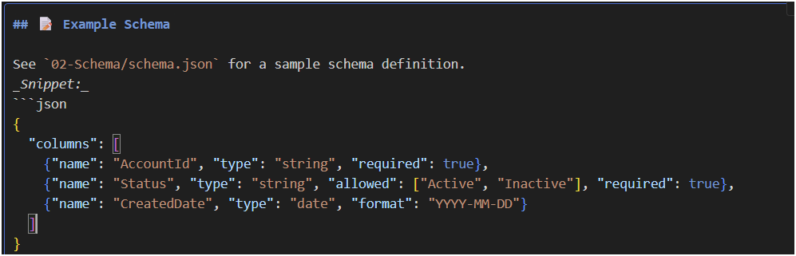

After Quick Start or Before Full Setup
Add:
🖥 UI Features
📂 Local file selection and upload
🧹 Auto-fix summary and audit log
✅❌ Schema validation status (with errors/warnings)
📊 Data quality summary
🧠 Analytics results (priority, risk, opportunity)
📥 Downloadable outputs
🕒 Run metadata (timestamp, row count, etc.)

After Install dependencies in Full Setup
Add:
📚 Dependency Justification
`pandas` - Data loading and cleaning
`flask` - Local web UI
`jsonschema` - Schema validation
`openpyxl` - Excel file support

To check which setup steps you need and get detailed info or commands, follow these tips:
For each step, run the commands in the Visual Studio Code Terminal (bottom panel, tab named "Terminal").

How to do it:
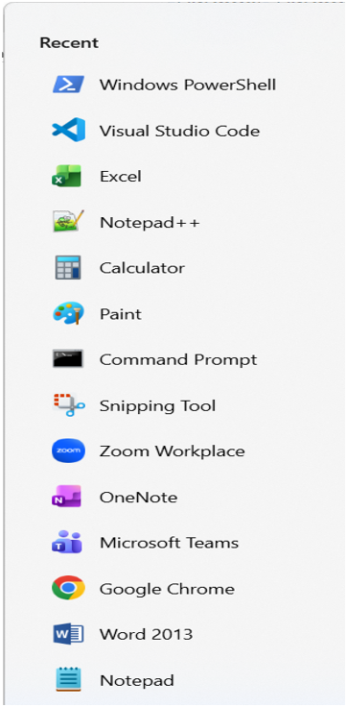

Open Visual Studio Code.
Open the Terminal (menu: View > Terminal).
Make sure you are in the Phase1-LocalInsights folder. If not, use:
CD C:\MyCode\cx-ai-local\LocalAIAgent-Phase1

Output Window:
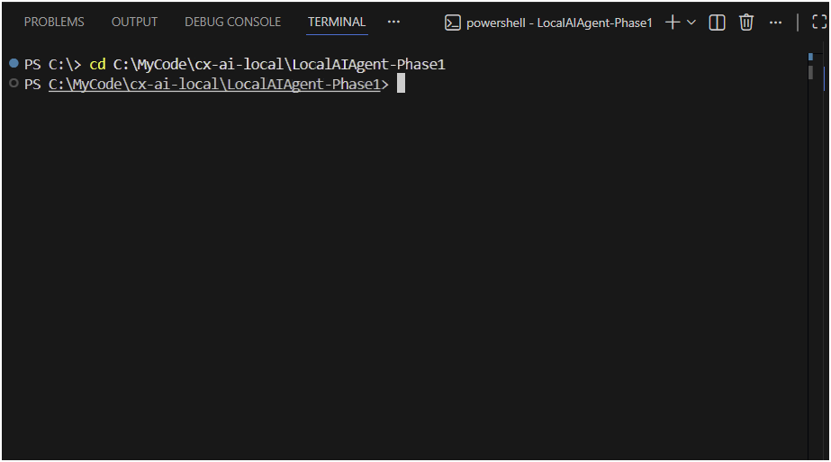
2. Create and activate a Python virtual environment:
python -m venv .venv
.venv\Scripts\activate

3. Install required dependencies (If not there)
pip install --upgrade pip
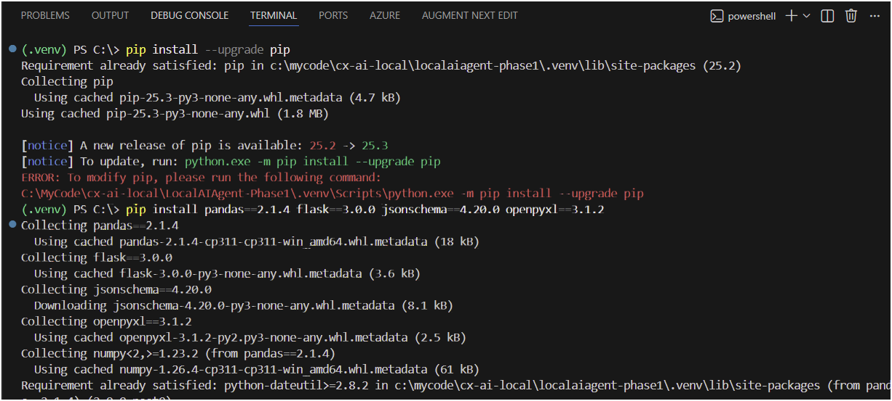
pip install pandas==2.1.4 flask==3.0.0 jsonschema==4.20.0 openpyxl==3.1.2

4. Once successfully installed required dependencies.
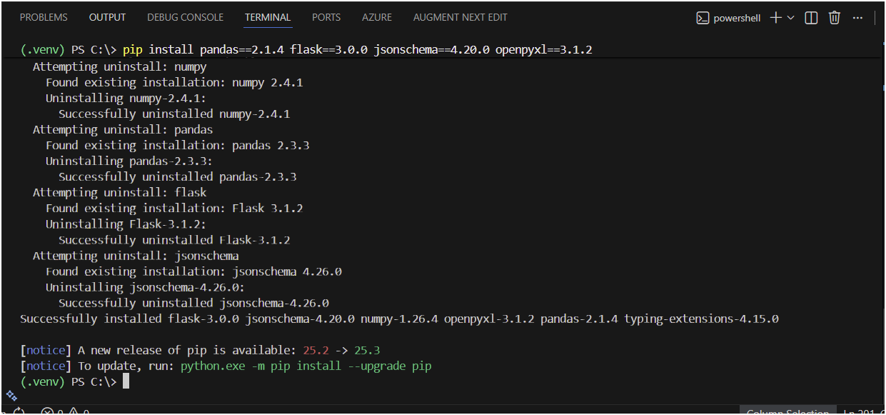
5. Ensure output folders exist:
if (-not (Test-Path "05-Outputs\autofix-audit")) { New-Item -ItemType Directory -Path "05-Outputs\autofix-audit" -Force }
if (-not (Test-Path "05-Outputs\validation-reports")) { New-Item -ItemType Directory -Path "05-Outputs\validation-reports" -Force }
6. The setup checks for the following folders inside your project directory:
- autofix-audit
- validation-reports

Why These Folders Are Checked
These folders are required for saving the results generated by the pipeline:
- autofix-audit: Stores audit logs of data cleaning actions
- validation-reports: Stores data validation reports

Why It Matters
The application requires these folders to exist before writing any output. If they are missing, file writes will fail.

If Missing
- Pipeline/UI may throw errors or crash
- Output files like audit-log.json and report.json won’t be created
- You must manually create the folders and rerun the pipeline

7. The next step is to start the UI application so you can use the web dashboard to upload files and run the pipeline.
The next step is to start the UI application so you can use the web dashboard to upload files and run the pipeline.

Here’s what to do:
Navigate to the UI folder:
cd C:\MyCode\cx-ai-local\LocalAIAgent-Phase1

Next steps:
Navigate to the UI folder:
cd 04-UI
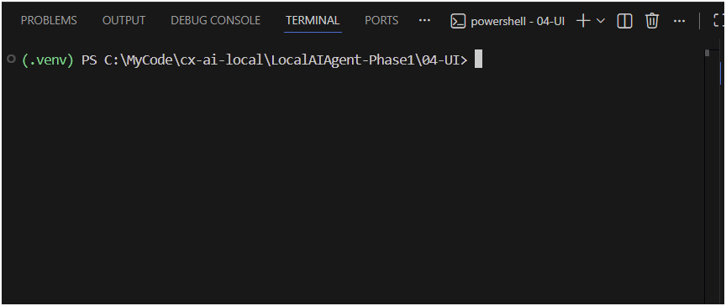

8. Start the Flask app:
python app.py
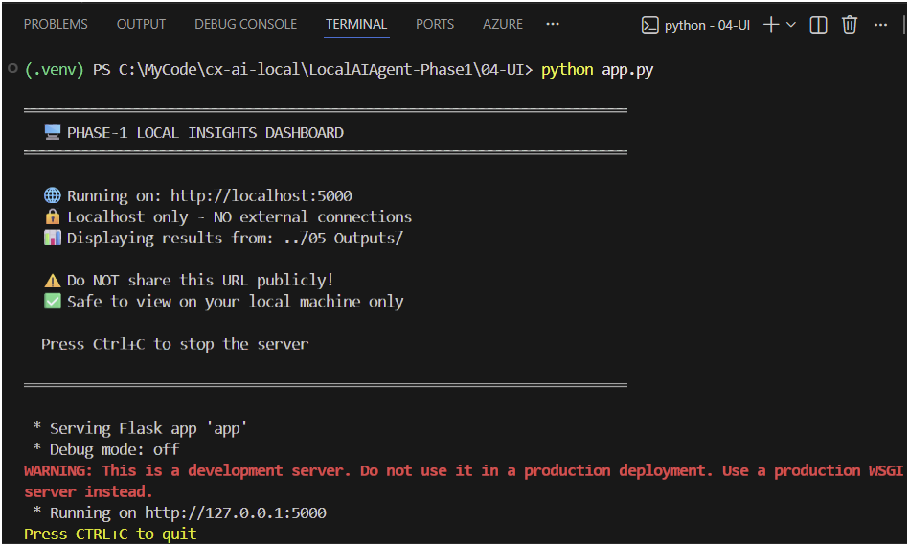

Why needed
Starts the Local Insights Dashboard (web UI) for your data pipeline.

Purpose
Provides a browser-based interface to:
- Upload CSV/Excel files
- Run data cleaning and validation
- View cleaned data, audit logs, and validation reports

✅ Business Requirements & Constraints Covered
🔒 Data & Trust
- 100% local execution (localhost only)
- No cloud, no telemetry, no external APIs
- Data never leaves your machine
- Fully auditable and explainable processing

🗂 Data Intake & Pre-Processing
- Accepts only CSV/XLSX files
- Deterministic auto-fix (trim, casing, dates, dedup, etc.)
- All changes logged in audit reports
- AI never reads files directly

🛡 Schema Validation
- Strict schema, type, format, and null checks
- Processing stops on failure with clear errors

📊 Phase-1 Analytics
- Rule-based, explainable scoring and metrics
- No black-box models

💾 Outputs & Storage
- All outputs saved locally
- Cleaned data, audit logs, validation reports

🖥 Localhost UI
- Simple, executive-friendly dashboard
- Fully offline and secure

📋 Deliverables & Style**
- Clear diagrams, schemas, and output templates
- Minimal dependencies
- Plain language, icons, and short sections

How to run
- Activate your virtual environment
- Go to the 04-UI folder
- Run the command
- Open: http://127.0.0.1:5000
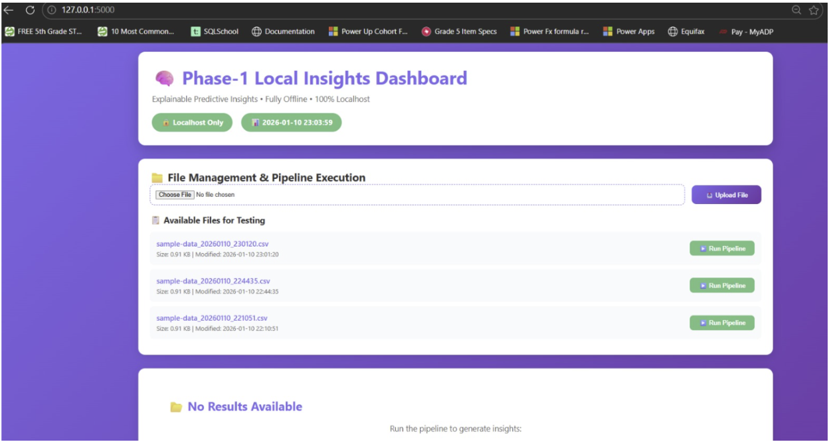
9. Dashboard Started Successfully
Access it at: http://127.0.0.1:5000
Next Steps
- Upload a File
  - Click Choose File
  - Select a CSV or Excel file (max 16 MB, must match schema)
  - Click Upload File
- Run the Pipeline
  - Find your file under Available Files for Testing
  - Click Run Pipeline
- Review Results
  - View results directly in the dashboard
  - Output files are saved in 05-Outputs:
    - cleaned-data.csv
    - autofix-audit/audit-log.json
    - validation-reports/report.json
- (Optional) Download Outputs
  - Download from the UI or open them from the output folder

